**Homework 1**

|  |  |  |  |
| --- | --- | --- | --- |
| ***year*** | ***Byte*** | ***year*** | ***Byte*** |
| 1970 | 262144 | 1990 | 2097152 |
| 1971 | 262144 | 1991 | 16777216 |
| 1972 | 262144 | 1992 | 16777216 |
| 1973 | 262144 | 1993 | 16777216 |
| 1974 | 262144 | 1994 | 16777216 |
| 1975 | 262144 | 1995 | 16777216 |
| 1976 | 262144 | 1996 | 268435456 |
| 1977 | 262144 | 1997 | 268435456 |
| 1978 | 262144 | 1998 | 1073741824 |
| 1979 | 262144 | 1999 | 1073741824 |
| 1980 | 262144 | 2000 | 1073741824 |
| 1981 | 262144 | 2004 | 4294967296 |
| 1982 | 262144 | 2009 | 8589934592 |
| 1988 | 2097152 | 2014 | 17179869184 |
| 1989 | 2097152 |  |  |

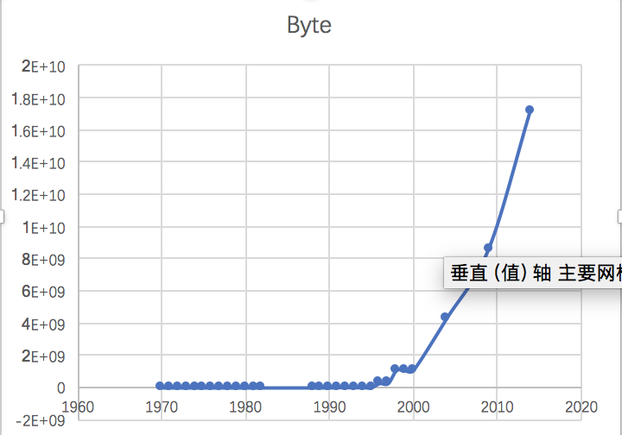

1. **logistic regression**



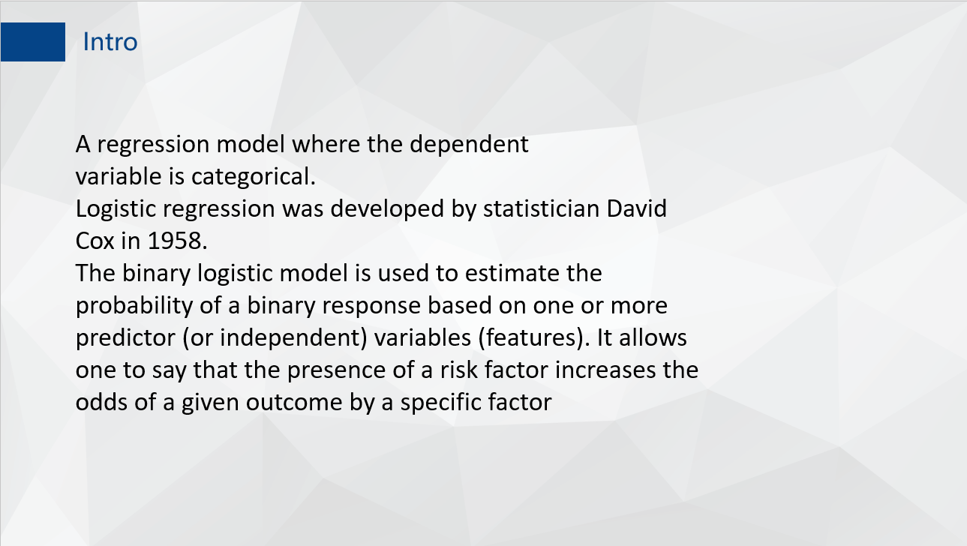

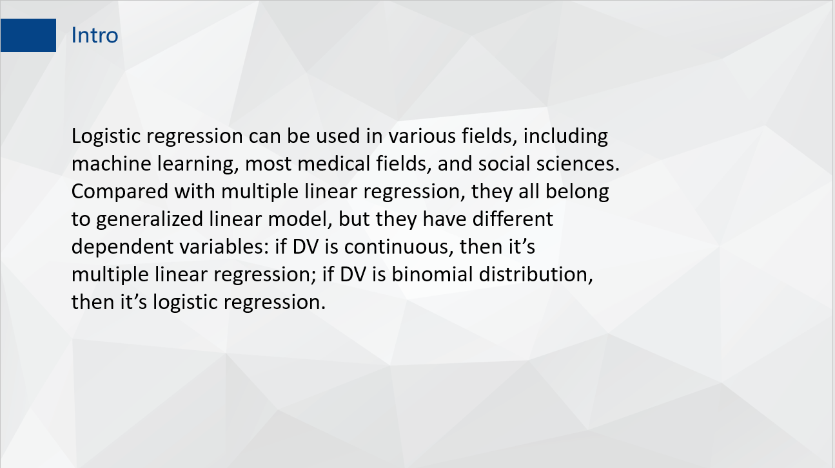

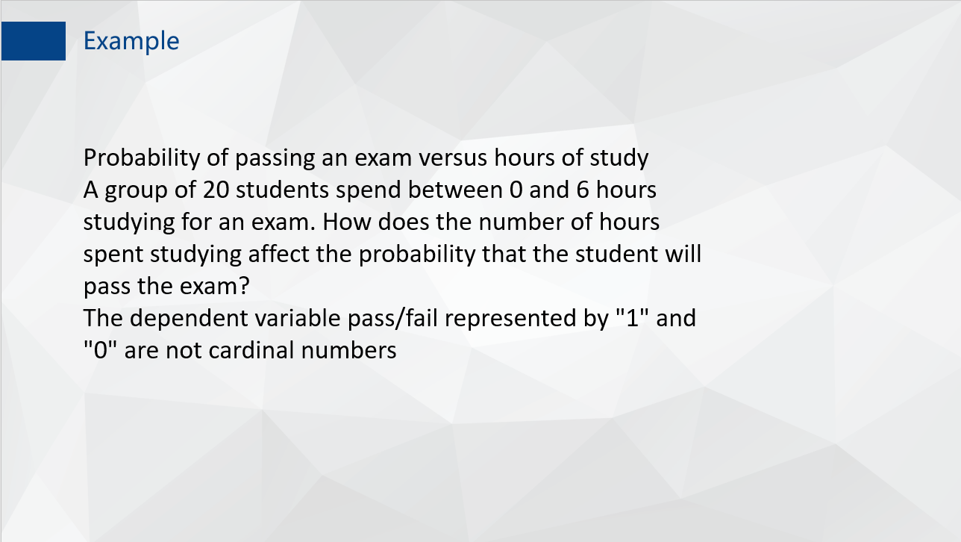

1. **Github Account:**  <https://github.com/Simon2274/Home-Work-for-BDIF>

**Homework 2**

1. **Use R to solve HW #1**

library(readr)

RAM_size <- read_csv("~/R data/Home-Work-for-BDIF/RAM_size.csv")

plot(RAM_size,type="l",xlab = "time",ylab = "size",lwd=3)

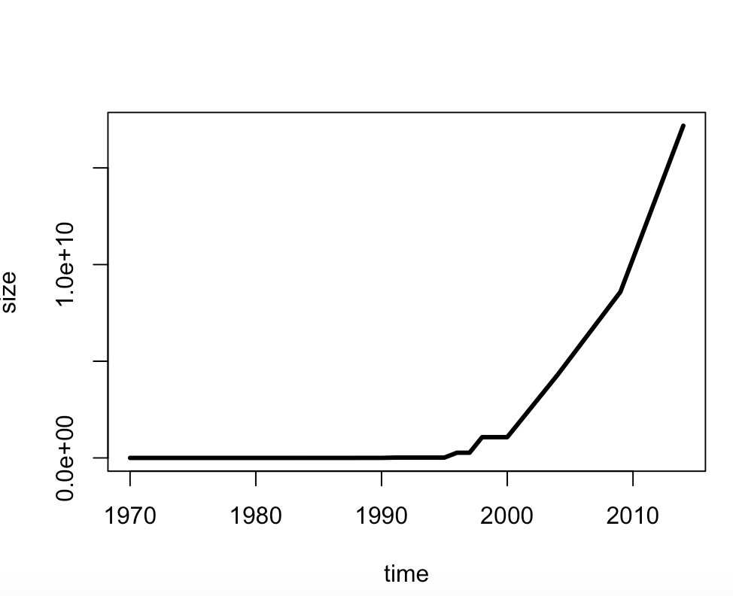

1. **use R with B-spline code to solve HW#1**

splines.reg.l1 = smooth.spline(x = RAM_size$year, y = RAM_size$Byte, spar = 0.2) # lambda = 0.2

splines.reg.l2 = smooth.spline(x = RAM_size$year, y = RAM_size$Byte, spar = 1) # lambda = 1

splines.reg.l3 = smooth.spline(x = RAM_size$year, y = RAM_size$Byte, spar = 2) # lambda = 2

lines(splines.reg.l1, col = "red", lwd = 1) # regression line with lambda = 0.2

lines(splines.reg.l2, col = "green", lwd = 1) # regression line with lambda = 1

lines(splines.reg.l3, col = "blue", lwd = 1) # regression line with lambda = 2

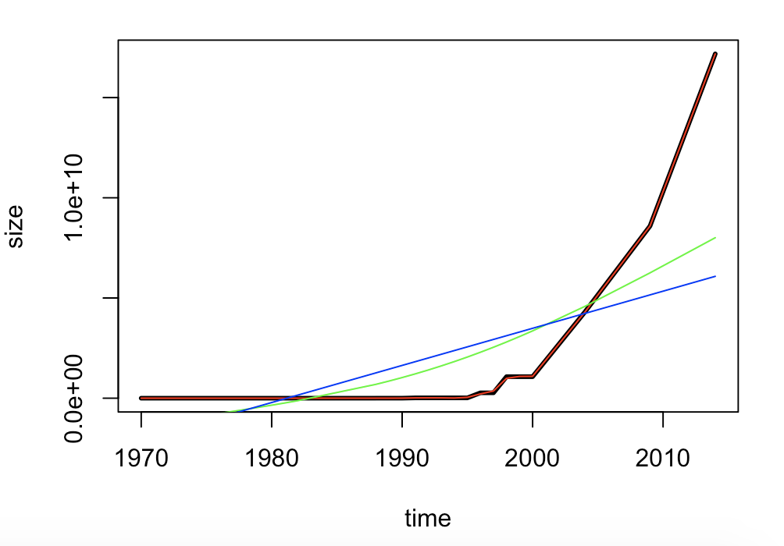

Comments: The larger the spar is, more smooth the line is.

1. **Poisson Distribution**

lambda=4

x=6

dpois(x,lambda)

lambda=5

x=0

dpois(x,lambda)

**Homework 3**

1. **hash code**

#install.packages("digest",repos='http://cran.us.r-projest.org')

library(digest)

digest("I learn a lot from this class when I am proper listening to the professor","sha256")

digest("I do not learn a lot from this class when I am absent and playing on my Iphone","sha256")

1. **Digital Signature Algorithms**



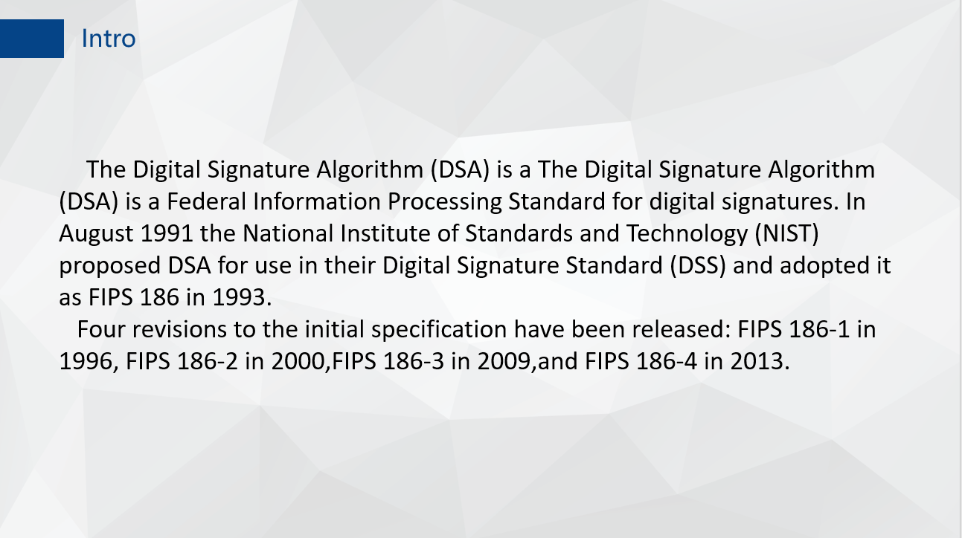

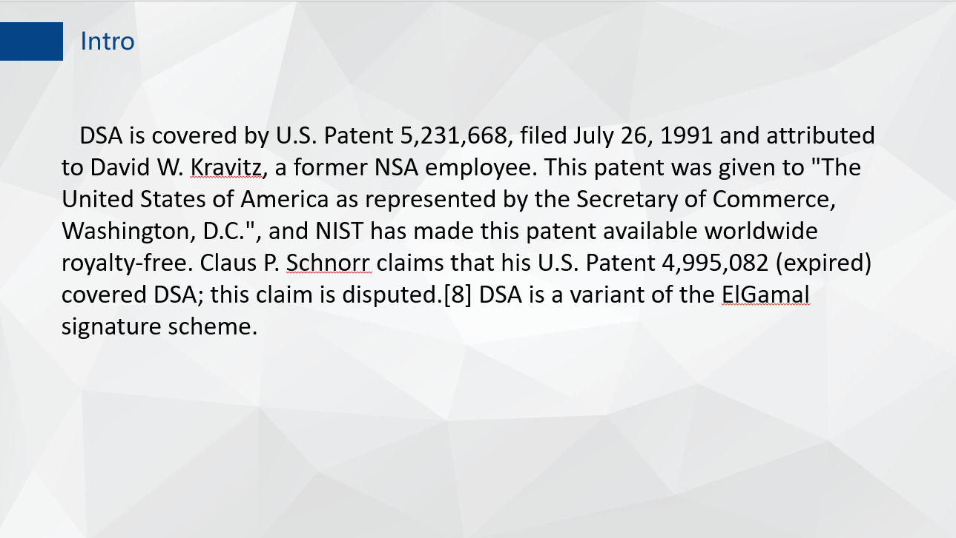

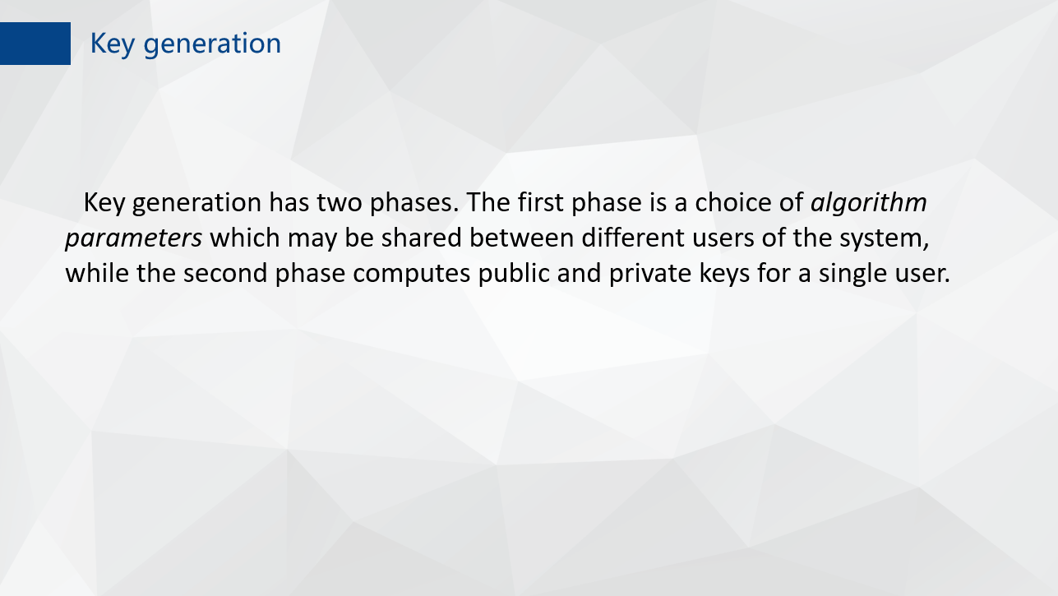

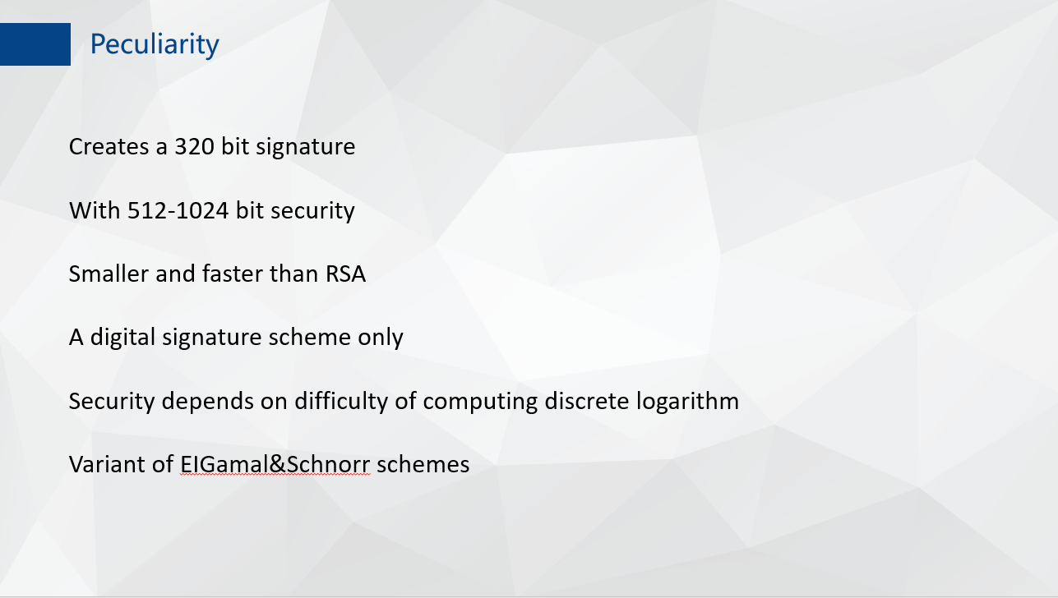

1. **Json data**

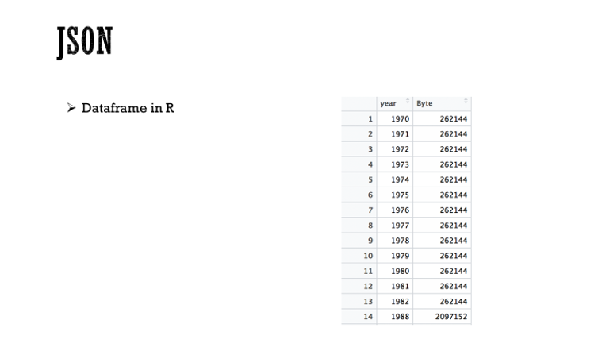

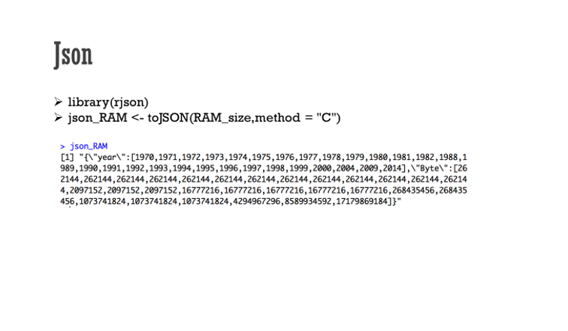

1. **CRIX data**

#install.packages("rjson", repos="http://cran.us.r-project.org")

library(rjson)

json_file = "http://crix.hu-berlin.de/data/crix.json"

json_data = fromJSON(file=json_file)

lst <- lapply(json_data,function(x){

df<-data.frame(date=x$date,price=x$price)

return(df)

})

crix_data_frame <- Reduce(rbind,lst)

plot(crix_data_frame$date,crix_data_frame$price)

#install.packages("forecast")

#install.packages("tseries")

library(forecast)

library(tseries)

ts.plot(crix_data_frame$price)

Acf(crix_data_frame$price)

for(i in 1:length(crix_data_frame$price)){

crixreturn[i] <- log(crix_data_frame$price[i+1]/crix_data_frame$price[i])

}

ts.plot(crixreturn)

Box.test(crixreturn, type = "Ljung-Box", lag = 20)

autocorr = acf(crixreturn, lag.max = 20, ylab = "Sample Autocorrelation", main = NA, lwd = 2, ylim = c(-0.3, 1))

Acf(crixreturn)

Pacf(crixreturn)

arima(crixreturn,order = c(2,0,2))

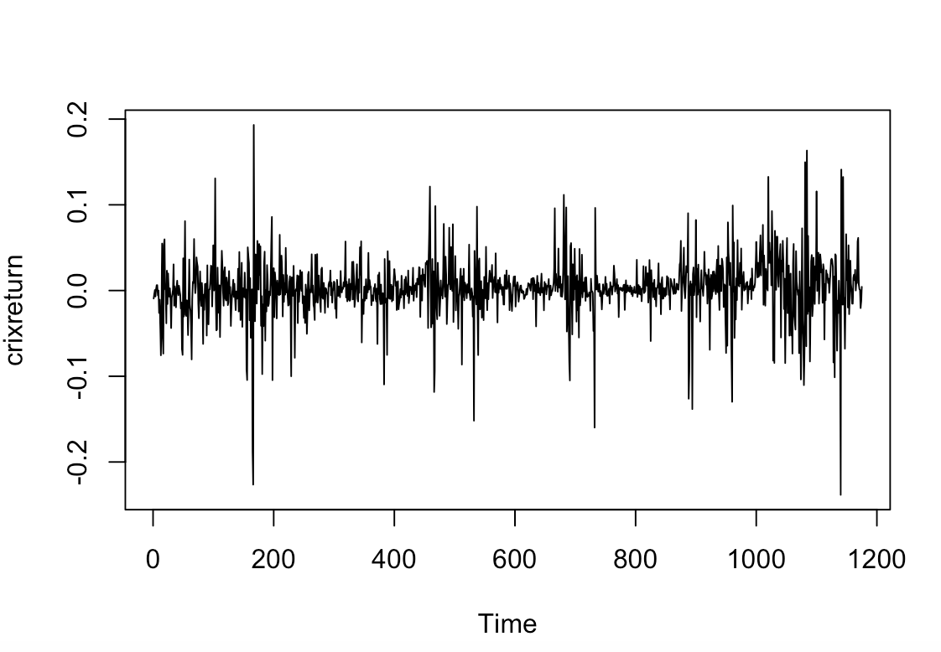

**Homework 4**



1. **Figure3,4,5,6**

#HW4.1

library(rjson)

json_file = "http://crix.hu-berlin.de/data/crix.json"

json_data = fromJSON(file=json_file)

lst <- lapply(json_data,function(x){

df<-data.frame(date=x$date,price=x$price)

return(df)

})

crix_data_frame <- Reduce(rbind,lst)

crix_data_frame <- crix_data_frame[-1,]

load(file = "ecrix.RData")

load(file = "efcrix.RData")

length(ecrix)=length(crix_data_frame$price)

length(efcrix)=length(crix_data_frame$price)

ecrix_data_frame <- as.data.frame(ecrix)

efcrix_data_frame <- as.data.frame(efcrix)

#install.packages("dplyr")

library(dplyr)

sum_crix <- cbind(crix_data_frame,ecrix_data_frame,efcrix_data_frame)

#figure3

ts.plot(sum_crix$price)

lines(sum_crix$price,col="black",lwd=0.5)

lines(sum_crix$ecrix,col="blue",lwd=1)

lines(sum_crix$efcrix,col="red",lwd=1)

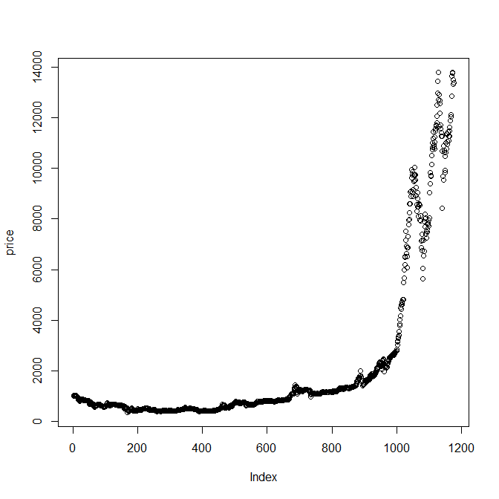

#figure4

crixreturn <- diff(log(crix_data_frame$price))

ts.plot(crixreturn)

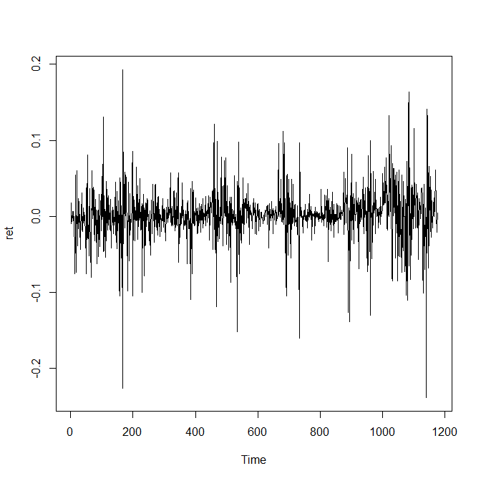

#figure5

hist(crixreturn,col = "grey",breaks = 20,freq = FALSE,ylim = c(0,25),xlab = NA)

lines(density(crixreturn),lwd=1)

mu = mean(crixreturn)

sigma = sd(crixreturn)

x = seq(-4, 4, length = 100)

curve(dnorm(x, mean = mean(crixreturn), sd = sd(crixreturn)), add = TRUE, col = "darkblue", lwd = 1)

qqnorm(crixreturn)

qqline(crixreturn, col = "blue", lwd = 2)

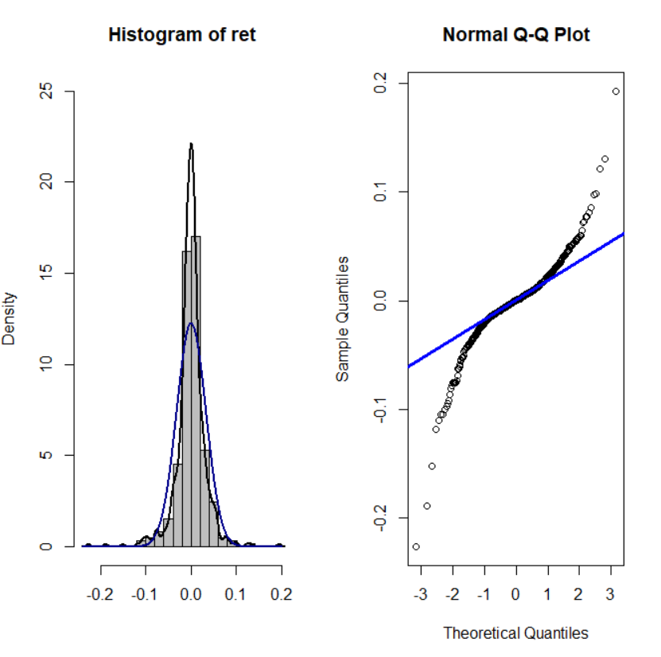

#figure6

Box.test(crixreturn, type = "Ljung-Box", lag = 20)

adf.test(crixreturn, alternative = "stationary")

kpss.test(crixreturn, null = "Trend")

par(mfrow = c(1, 2))

autocorr = acf(crixreturn, lag.max = 20, ylab = "Sample Autocorrelation", main = NA, lwd = 2, ylim = c(-0.3, 1))

print(cbind(autocorr$lag, autocorr$acf))

Box.test(crixreturn, type = "Ljung-Box", lag = 1, fitdf = 0)

Box.test(autocorr$acf, type = "Ljung-Box")

autopcorr = pacf(crixreturn, lag.max = 20, ylab = "Sample Partial Autocorrelation",main = NA, ylim = c(-0.3, 0.3), lwd = 2)

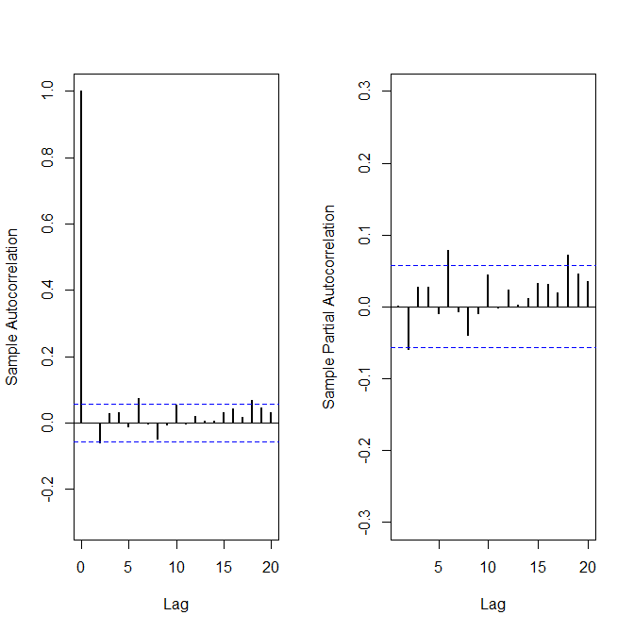

1. **Figure 7**

par(mfrow = c(1, 1))

auto.arima(crixreturn)

fit1 = arima(crixreturn, order = c(1, 0, 1))

tsdiag(fit1)

Box.test(fit1$residuals, lag = 1)

aic = matrix(NA, 6, 6)

for (p in 0:4) {

for (q in 0:3) {

a.p.q = arima(crixreturn, order = c(p, 0, q))

aic.p.q = a.p.q$aic

aic[p + 1, q + 1] = aic.p.q

}

}

aic

bic = matrix(NA, 6, 6)

for (p in 0:4) {

for (q in 0:3) {

b.p.q = arima(crixreturn, order = c(p, 0, q))

bic.p.q = AIC(b.p.q, k = log(length(crixreturn)))

bic[p + 1, q + 1] = bic.p.q

}

}

bic

fit4 = arima(crixreturn, order = c(2, 0, 3))

tsdiag(fit4)

Box.test(fit4$residuals, lag = 1)

fitr4 = arima(crixreturn, order = c(2, 1, 3))

tsdiag(fitr4)

Box.test(fitr4$residuals, lag = 1)

fit202 = arima(crixreturn, order = c(2, 0, 2))

tsdiag(fit202)

tsdiag(fit4)

tsdiag(fitr4)

AIC(fit202, k = log(length(crixreturn)))

AIC(fit4, k = log(length(crixreturn)))

AIC(fitr4, k = log(length(crixreturn)))

fit202$aic

fit4$aic

fitr4$aic

fit202 = arima(crixreturn, order = c(2, 0, 2))

crpre = predict(fit202, n.ahead = 30)

dates = seq(as.Date("02/08/2014", format = "%d/%m/%Y"), by = "days", length = length(crixreturn))

plot(crixreturn, type = "l", xlim = c(0, 1200), ylab = "log return", xlab = "days", lwd = 1)

lines(crpre$pred, col = "red", lwd = 3)

lines(crpre$pred + 2 * crpre$se, col = "red", lty = 3, lwd = 3)

lines(crpre$pred - 2 * crpre$se, col = "red", lty = 3, lwd = 3)

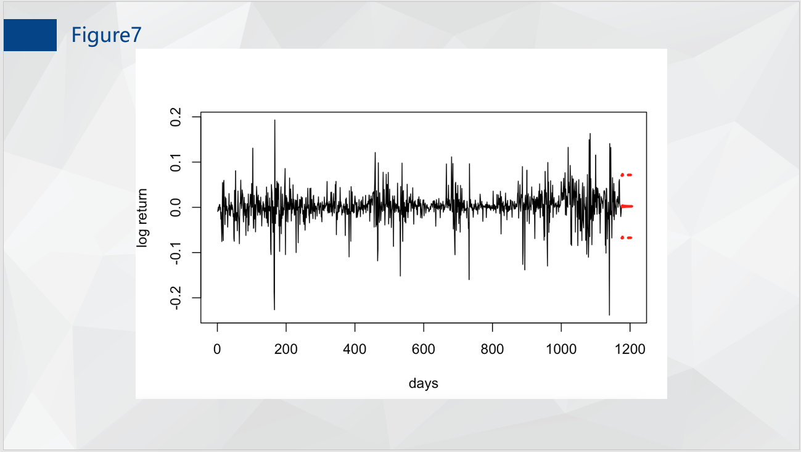

HW 5

Q1

rm(list = ls())

#install.packages("RCurl")

#install.packages("XML")

library(RCurl)

library(XML)

url1 = "http://shakespeare.mit.edu/romeo_juliet/full.html"

url2 = "http://shakespeare.mit.edu/julius_caesar/full.html"

url3 = "http://shakespeare.mit.edu/hamlet/full.html"

html1 = readLines(url1, encoding = "UTF-8")

html2 = readLines(url2, encoding = "UTF-8")

html3 = readLines(url3, encoding = "UTF-8")

html1 = htmlParse(html1, encoding = "UTF-8")

html2 = htmlParse(html2, encoding = "UTF-8")

html3 = htmlParse(html3, encoding = "UTF-8")

#install.packages("bitops")

#install.packages("stringr")

library(bitops)

library(stringr)

abs1 = lapply(url1, FUN = function(x) htmlParse(x, encoding = "Latin-1"))

abs2 = lapply(url2, FUN = function(x) htmlParse(x, encoding = "Latin-1"))

abs3 = lapply(url3, FUN = function(x) htmlParse(x, encoding = "Latin-1"))

clean_txt = function(x) {

cleantxt = xpathApply(x, "//body//text()

[not(ancestor :: script)][ not(ancestor :: style)]

[not(ancestor :: noscript)] " ,xmlValue)

cleantxt = paste(cleantxt, collapse="\n")

cleantxt = str_replace_all(cleantxt, "\n", " ")

cleantxt = str_replace_all(cleantxt, "\r", "")

cleantxt = str_replace_all(cleantxt, "\t", "")

cleantxt = str_replace_all(cleantxt, "<br>", "")

return(cleantxt)

}

cleantxt1 = lapply(abs1,clean_txt)

cleantxt2 = lapply(abs2,clean_txt)

cleantxt3 = lapply(abs3,clean_txt)

vec_abs1 = unlist(cleantxt1)

vec_abs2 = unlist(cleantxt2)

vec_abs3 = unlist(cleantxt3)

###Text Mining

install.packages("tm")

install.packages("SnowballC")

library(tm)

library(SnowballC)

abs1 = Corpus(VectorSource(vec_abs1))

abs2 = Corpus(VectorSource(vec_abs2))

abs3 = Corpus(VectorSource(vec_abs3))

abs_dtm1 = DocumentTermMatrix(abs1, control = list(

stemming = TRUE, stopwords = TRUE, minWordLength = 3,

removeNumbers = TRUE, removePunctuation = TRUE))

abs_dtm2 = DocumentTermMatrix(abs2, control = list(

stemming = TRUE, stopwords = TRUE, minWordLength = 3,

removeNumbers = TRUE, removePunctuation = TRUE))

abs_dtm3 = DocumentTermMatrix(abs3, control = list(

stemming = TRUE, stopwords = TRUE, minWordLength = 3,

removeNumbers = TRUE, removePunctuation = TRUE))

##WordCloud

instal.packages("ggplot2")

install.packages("wordcloud")

library(ggplot2)

library(wordcloud)

freq1 = colSums(as.matrix(abs_dtm1))

freq2 = colSums(as.matrix(abs_dtm2))

freq3 = colSums(as.matrix(abs_dtm3))

wf1 = data.frame(word=names(freq1), freq=freq1)

wf2 = data.frame(word=names(freq2), freq=freq2)

wf3 = data.frame(word=names(freq3), freq=freq3)

#Romeo and Juliet

plot1 = ggplot(subset(wf1, freq>15), aes(word, freq1))

plot1 = plot1 + geom_bar(stat="identity")

plot1 = plot1 + theme(axis.text.x=element_text(angle=45, hjust=1))

plot1

freq1 = colSums(as.matrix(abs_dtm1))

dark2_1 = brewer.pal(6, "Dark2")

wordcloud(names(freq1), freq1, max.words=100, rot.per=0.2, colors=dark2_1)

#Julius Caeser

plot2 = ggplot(subset(wf2, freq>15), aes(word, freq2))

plot2 = plot2 + geom_bar(stat="identity")

plot2 = plot2 + theme(axis.text.x=element_text(angle=45, hjust=1))

plot2

freq2 = colSums(as.matrix(abs_dtm2))

dark2_2 = brewer.pal(6, "Dark2")

wordcloud(names(freq2), freq2, max.words=100, rot.per=0.2, colors=dark2_2)

#Hamlet

plot3 = ggplot(subset(wf3, freq>15), aes(word, freq3))

plot3 = plot3 + geom_bar(stat="identity")

plot3 = plot3 + theme(axis.text.x=element_text(angle=45, hjust=1))

plot3

freq3 = colSums(as.matrix(abs_dtm3))

dark2_3 = brewer.pal(6, "Dark2")

wordcloud(names(freq3), freq3, max.words=100, rot.per=0.2, colors=dark2_3)

#Romeo and Juliet

plot1 = ggplot(subset(wf1, freq>15), aes(word, freq1))

plot1 = plot1 + geom_bar(stat="identity")

plot1 = plot1 + theme(axis.text.x=element_text(angle=45, hjust=1))

plot1

freq1 = colSums(as.matrix(abs_dtm1))

dark2_1 = brewer.pal(6, "Dark2")

wordcloud(names(freq1), freq1, max.words=100, rot.per=0.2, colors=dark2_1)

#Julius Caeser

plot2 = ggplot(subset(wf2, freq>15), aes(word, freq2))

plot2 = plot2 + geom_bar(stat="identity")

plot2 = plot2 + theme(axis.text.x=element_text(angle=45, hjust=1))

plot2

freq2 = colSums(as.matrix(abs_dtm2))

dark2_2 = brewer.pal(6, "Dark2")

wordcloud(names(freq2), freq2, max.words=100, rot.per=0.2, colors=dark2_2)

#Hamlet

plot3 = ggplot(subset(wf3, freq>15), aes(word, freq3))

plot3 = plot3 + geom_bar(stat="identity")

plot3 = plot3 + theme(axis.text.x=element_text(angle=45, hjust=1))

plot3

freq3 = colSums(as.matrix(abs_dtm3))

dark2_3 = brewer.pal(6, "Dark2")

wordcloud(names(freq3), freq3, max.words=100, rot.per=0.2, colors=dark2_3)

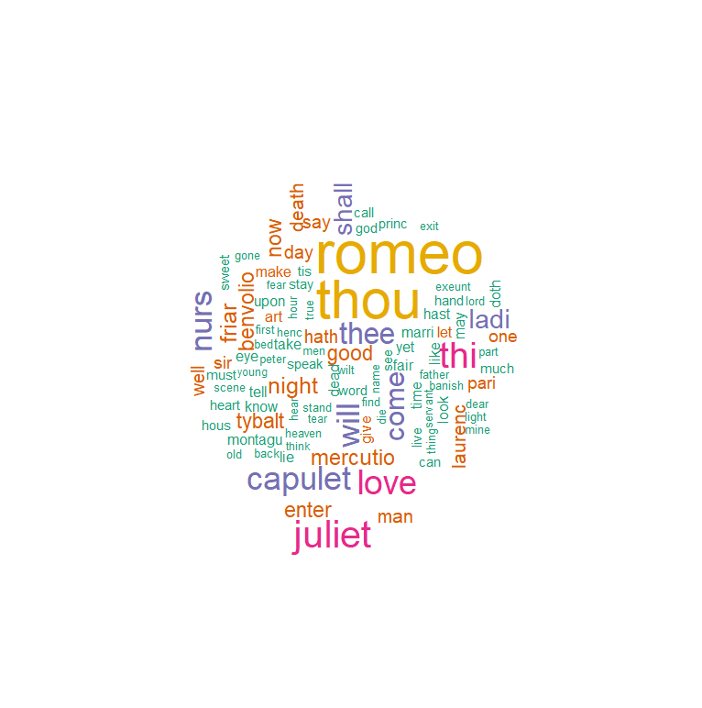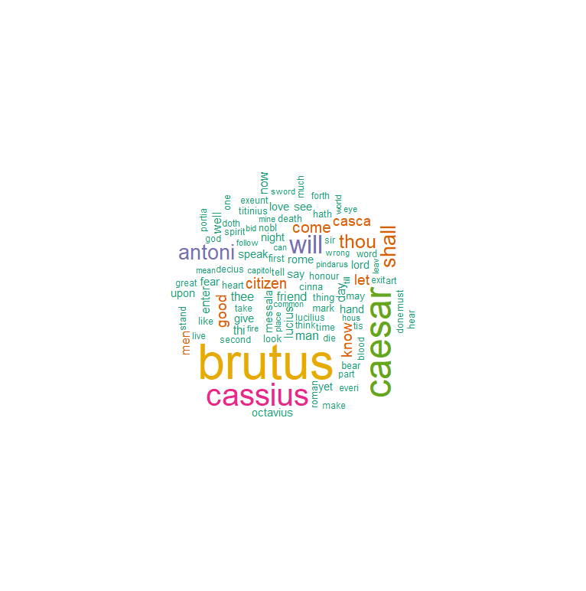

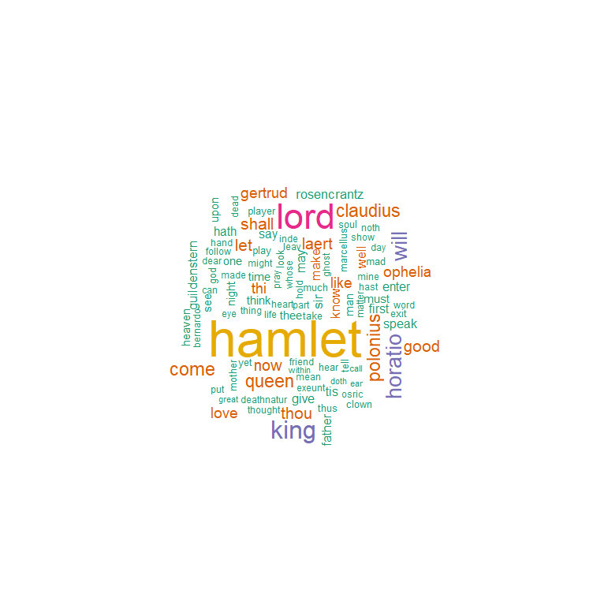

**Q2**

#Romeo and Juliet

wf1 <- wf1[order(-wf1$freq),]

wf1 <- wf1[c(1:20),]

p1 = ggplot(subset(wf1, freq > 15), aes(word, freq))

p1 = p1 + geom_bar(stat = "identity")

p1 = p1 + theme(axis.text.x = element_text(angle = 45, hjust = 1))

p1

#Julius Caeser

wf2 <- wf2[order(-wf2$freq),]

wf2 <- wf2[c(1:20),]

p2 = ggplot(subset(wf2, freq > 15), aes(word, freq))

p2 = p2 + geom_bar(stat = "identity")

p2 = p2 + theme(axis.text.x = element_text(angle = 45, hjust = 1))

p2

#Hamlet

wf3 <- wf3[order(-wf3$freq),]

wf3 <- wf3[c(1:20),]

p3 = ggplot(subset(wf3, freq > 15), aes(word, freq))

p3 = p3 + geom_bar(stat = "identity")

p3 = p3 + theme(axis.text.x = element_text(angle = 45, hjust = 1))

p3

